



**Batch: A4 Roll No.: 16010420117 Experiment: 4**

**Aim:** To study Convolutional Neural Networks architectures.



**Resources needed:**

**Theory:**



**Activity:**

1. Study textbooks and other web references and write in your own words about Construction, Basic working principles, network design, learning algorithms, and applications of newly developed Convolutional Neural Networks.
2. Compare these different types of CNN and write their applications in detail.
3. Generate plagiarism report of the write-ups submitted.

**Results:**

1. Study textbooks and other web references and write in your own words about Construction, Basic working principles, network design, learning algorithms, and applications of newly developed Convolutional Neural Networks.

**Convolutional Neural Network**

Convolutional Neural Networks (CNNs) are a type of deep learning algorithm used for image processing, recognition, and classification tasks. The basic working principle of a CNN involves inputting an image into the network, which is then convolved with a set of learnable filters to extract features at various spatial scales. These features are then passed through a series of nonlinear activation functions, pooling layers, and fully connected layers to make a prediction or classification.

1. Construction of CNNs:

CNNs are constructed by stacking several layers, including convolutional layers, pooling layers, and fully connected layers. Convolutional layers use filters to detect specific features in an image, pooling layers reduce the size of the feature maps, and fully connected layers perform classification based on the extracted features. CNNs can also include other layers such as normalization layers, dropout layers, and activation layers.

1. Basic Working Principles of CNNs:

The basic working principle of CNNs involves learning filters in convolutional layers that are applied to the entire image using a sliding window approach. The output of the convolutional layer is then fed into a pooling layer that reduces the size of the feature map while retaining the most important features. Finally, the output of the pooling layer is passed through fully connected layers that perform classification based on the extracted features.

1. Network Design of CNNs:

CNNs can be designed with different architectures, including LeNet, AlexNet, VGGNet, GoogleNet, and ResNet. These architectures vary in the number of layers, the number of filters, and the connections between layers. Some architectures use skip connections or residual connections to improve the performance of the network.

1. Learning Algorithms of CNNs:

CNNs are trained using backpropagation, which involves computing the gradient of the loss function with respect to the weights of the network and updating the weights using an optimizer such as stochastic gradient descent (SGD), Adam, or RMSprop. The loss function used for training can vary depending on the task, including mean squared error (MSE), cross-entropy, and binary cross-entropy.

1. Applications of CNNs:

CNNs have a wide range of applications, including image and video analysis, natural language processing, and speech recognition. In image analysis, CNNs can be used for object detection, segmentation, and recognition. In natural language processing, CNNs can be used for sentiment analysis, text classification, and machine translation. In speech recognition, CNNs can be used for speech-to-text conversion and speaker recognition.

2. Compare these different types of CNN and write their applications in detail.

1. LeNet was one of the earliest CNNs created and primarily used for handwritten digit recognition. The network has seven layers and is considered straightforward compared to more recent CNN models.
2. AlexNet was the first CNN to win the ImageNet Large Scale Visual Recognition Challenge in 2012. The network comprises eight layers and leverages ReLU activation functions and dropout regularization to improve performance.
3. VGGNet was created by the Visual Geometry Group at the University of Oxford and contains 19 layers. The network is lauded for its simplicity and use of small 3x3 filters throughout the architecture.
4. GoogLeNet, also known as Inception, uses multiple filter sizes concurrently to extract features at varying scales. The network employs an inception module, which allows it to learn the optimal filter size and depth for each layer, making it useful for object detection and localization tasks.
5. ResNet utilizes residual connections to prevent the issue of vanishing gradients, which can arise in deep neural networks. The network is commonly used for image recognition and segmentation tasks.
6. MobileNet is designed for mobile devices with limited computational resources. It utilizes depth wise separable convolutions to reduce the number of parameters in the network while maintaining accuracy, making it ideal for real-time object recognition and mobile applications.

The applications of these CNNs are contingent on their architecture and design. For instance, LeNet is well-suited for digit recognition, while AlexNet excels in object recognition. VGGNet is optimal for image recognition and segmentation tasks, and GoogLeNet/Inception is useful for object detection and localization. ResNet is frequently employed for image recognition and segmentation tasks, and MobileNet is ideal for real-time object recognition and mobile applications.

3. Generate plagiarism report of the write-ups submitted.

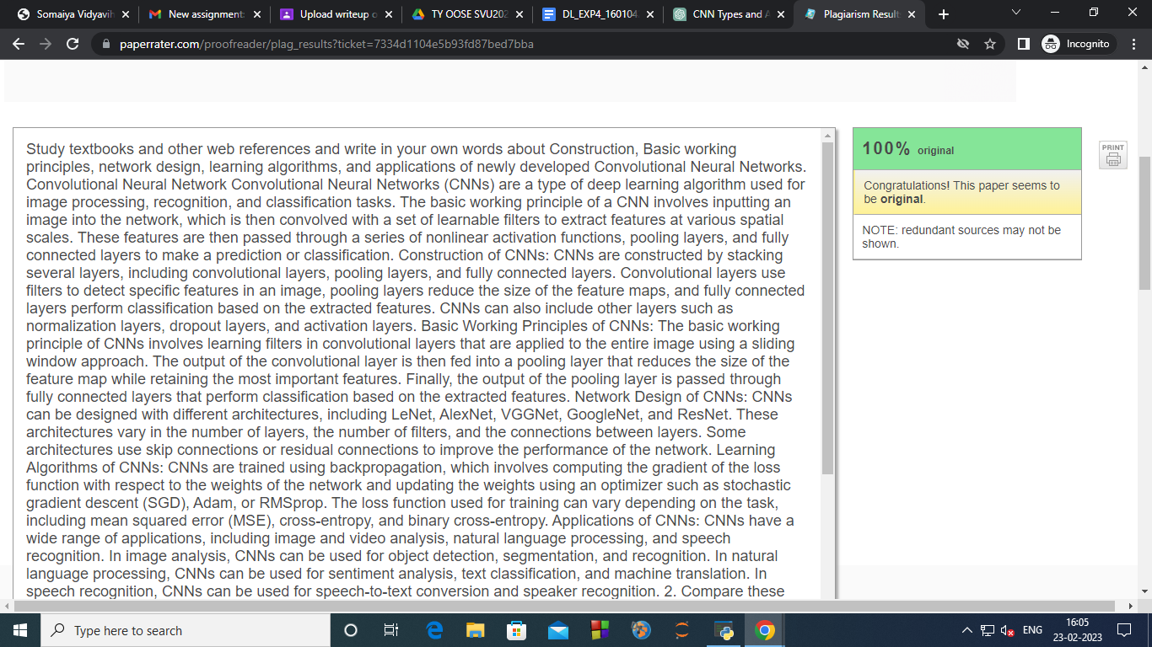

**CO: 3 Assimilate fundamentals of Convolutional Neural Network.**



**Conclusion: Successfully understood the Convolutional Neural Networks architectures.**

**Grade: AA / AB / BB / BC / CC / CD /DD**

**Signature of faculty in-charge with date**



**References:**

**Books/ Journals/ Websites:**